11/5/22, 1:25 AM Untitled2 - Jupyter Notebook

In [2]:

**import** pandas **as** pd

**import** numpy **as** np

**import** matplotlib.pyplot **as** plt

**import** seaborn **as** sns

**import** warnings

warnings.filterwarnings('ignore')

In [4]:

df**=**pd.read_csv('Downloads/Heart_Disease_Prediction.csv')

In [5]:

df.head()

Out[5]:

**Age Sex**

|  |  |  |  |  |  |  |  |  |  |  |  |
| --- | --- | --- | --- | --- | --- | --- | --- | --- | --- | --- | --- |
|  | | | **type** |  |  | **120 res** |  |  |  |  | **flu** |
| **0** | 70 | 1 | 4 | 130 | 322 | 0 | 2 | 109 | 0 | 2.4 | 2 |
| **1** | 67 | 0 | 3 | 115 | 564 | 0 | 2 | 160 | 0 | 1.6 | 2 |
| **2** | 57 | 1 | 2 | 124 | 261 | 0 | 0 | 141 | 0 | 0.3 | 1 |
| **3** | 64 | 1 | 4 | 128 | 263 | 0 | 0 | 105 | 1 | 0.2 | 2 |
| **4** | 74 | 0 | 2 | 120 | 269 | 0 | 2 | 121 | 1 | 0.2 | 1 |

**Chest pain**

**BP Cholesterol**

**FBS**

**over**

**EKG**

**ults**

**Max HR**

**Exercise angina**

**ST**

**depression**

**Slope of ST**

**Numb vesse**

|  |  |  |  |
| --- | --- | --- | --- |
| In | [6]: | | |
| df.isnull().sum() | |  |  |
| Out[6]: | |  |  |
| Age | |  | 0 |
| Sex | |  | 0 |
| Chest pain type | |  | 0 |
| BP | |  | 0 |
| Cholesterol | |  | 0 |
| FBS over 120 | |  | 0 |
| EKG results | |  | 0 |
| Max HR | |  | 0 |
| Exercise angina | |  | 0 |
| ST depression | |  | 0 |
| Slope of ST | |  | 0 |
| Number of vessels | | fluro | 0 |
| Thallium | |  | 0 |
| Heart Disease  dtype: int64 | |  | 0 |

11/5/22, 1:25 AM Untitled2 - Jupyter Notebook

In [7]:

print(df.info())

<class 'pandas.core.frame.DataFrame'> RangeIndex: 270 entries, 0 to 269

Data columns (total 14 columns):

# Column Non-Null Count Dtype

|  |  |  |  |  |  |  |  |  |  |  |
| --- | --- | --- | --- | --- | --- | --- | --- | --- | --- | --- |
| 0 |  | Age |  |  | | 270 | non-null |  | int64 |  |
| 1 |  | Sex |  |  | | 270 | non-null |  | int64 |
| 2 |  | Chest | pain | type | | 270 | non-null |  | int64 |
| 3 |  | BP |  |  | | 270 | non-null |  | int64 |
| 4 Cholesterol | | | | |  | 270 | non-null | int64 | | |
| 5 FBS over 120 | | | | |  | 270 | non-null | int64 | | |
| 6 EKG results | | | | |  | 270 | non-null | int64 | | |
| 7 Max HR | | | | |  | 270 | non-null | int64 | | |
| 8 Exercise angina | | | | |  | 270 | non-null | int64 | | |
| 9 ST depression | | | | |  | 270 | non-null | float64 | | |
| 10 Slope of ST | | | | |  | 270 | non-null | int64 | | |
| 11 Number of vessels | | | | | fluro | 270 | non-null | int64 | | |
| 12 Thallium | | | | |  | 270 | non-null | int64 | | |
| 13 Heart Disease | | | | |  | 270 | non-null | object | | |

dtypes: float64(1), int64(12), object(1) memory usage: 29.7+ KB

None

In [9]:

plt.figure(figsize**=**(20,10))

sns.heatmap(df.corr(), annot**=True**, cmap**=**'terrain')

Out[9]:

<AxesSubplot:>

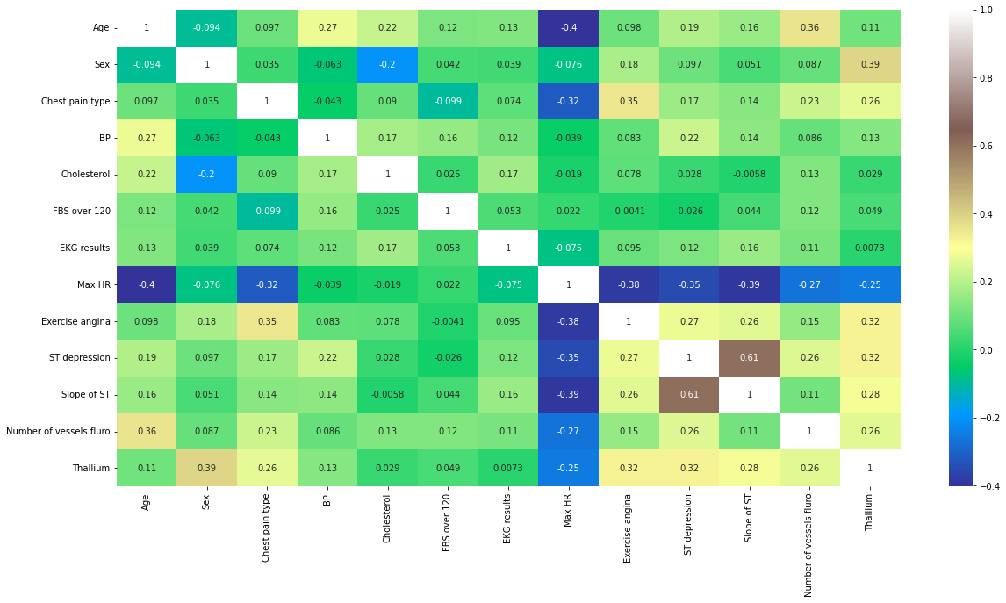

11/5/22, 1:25 AM Untitled2 - Jupyter Notebook

In [10]:

sns.pairplot(data**=**df)

Out[10]:

<seaborn.axisgrid.PairGrid at 0x2059aec2448>

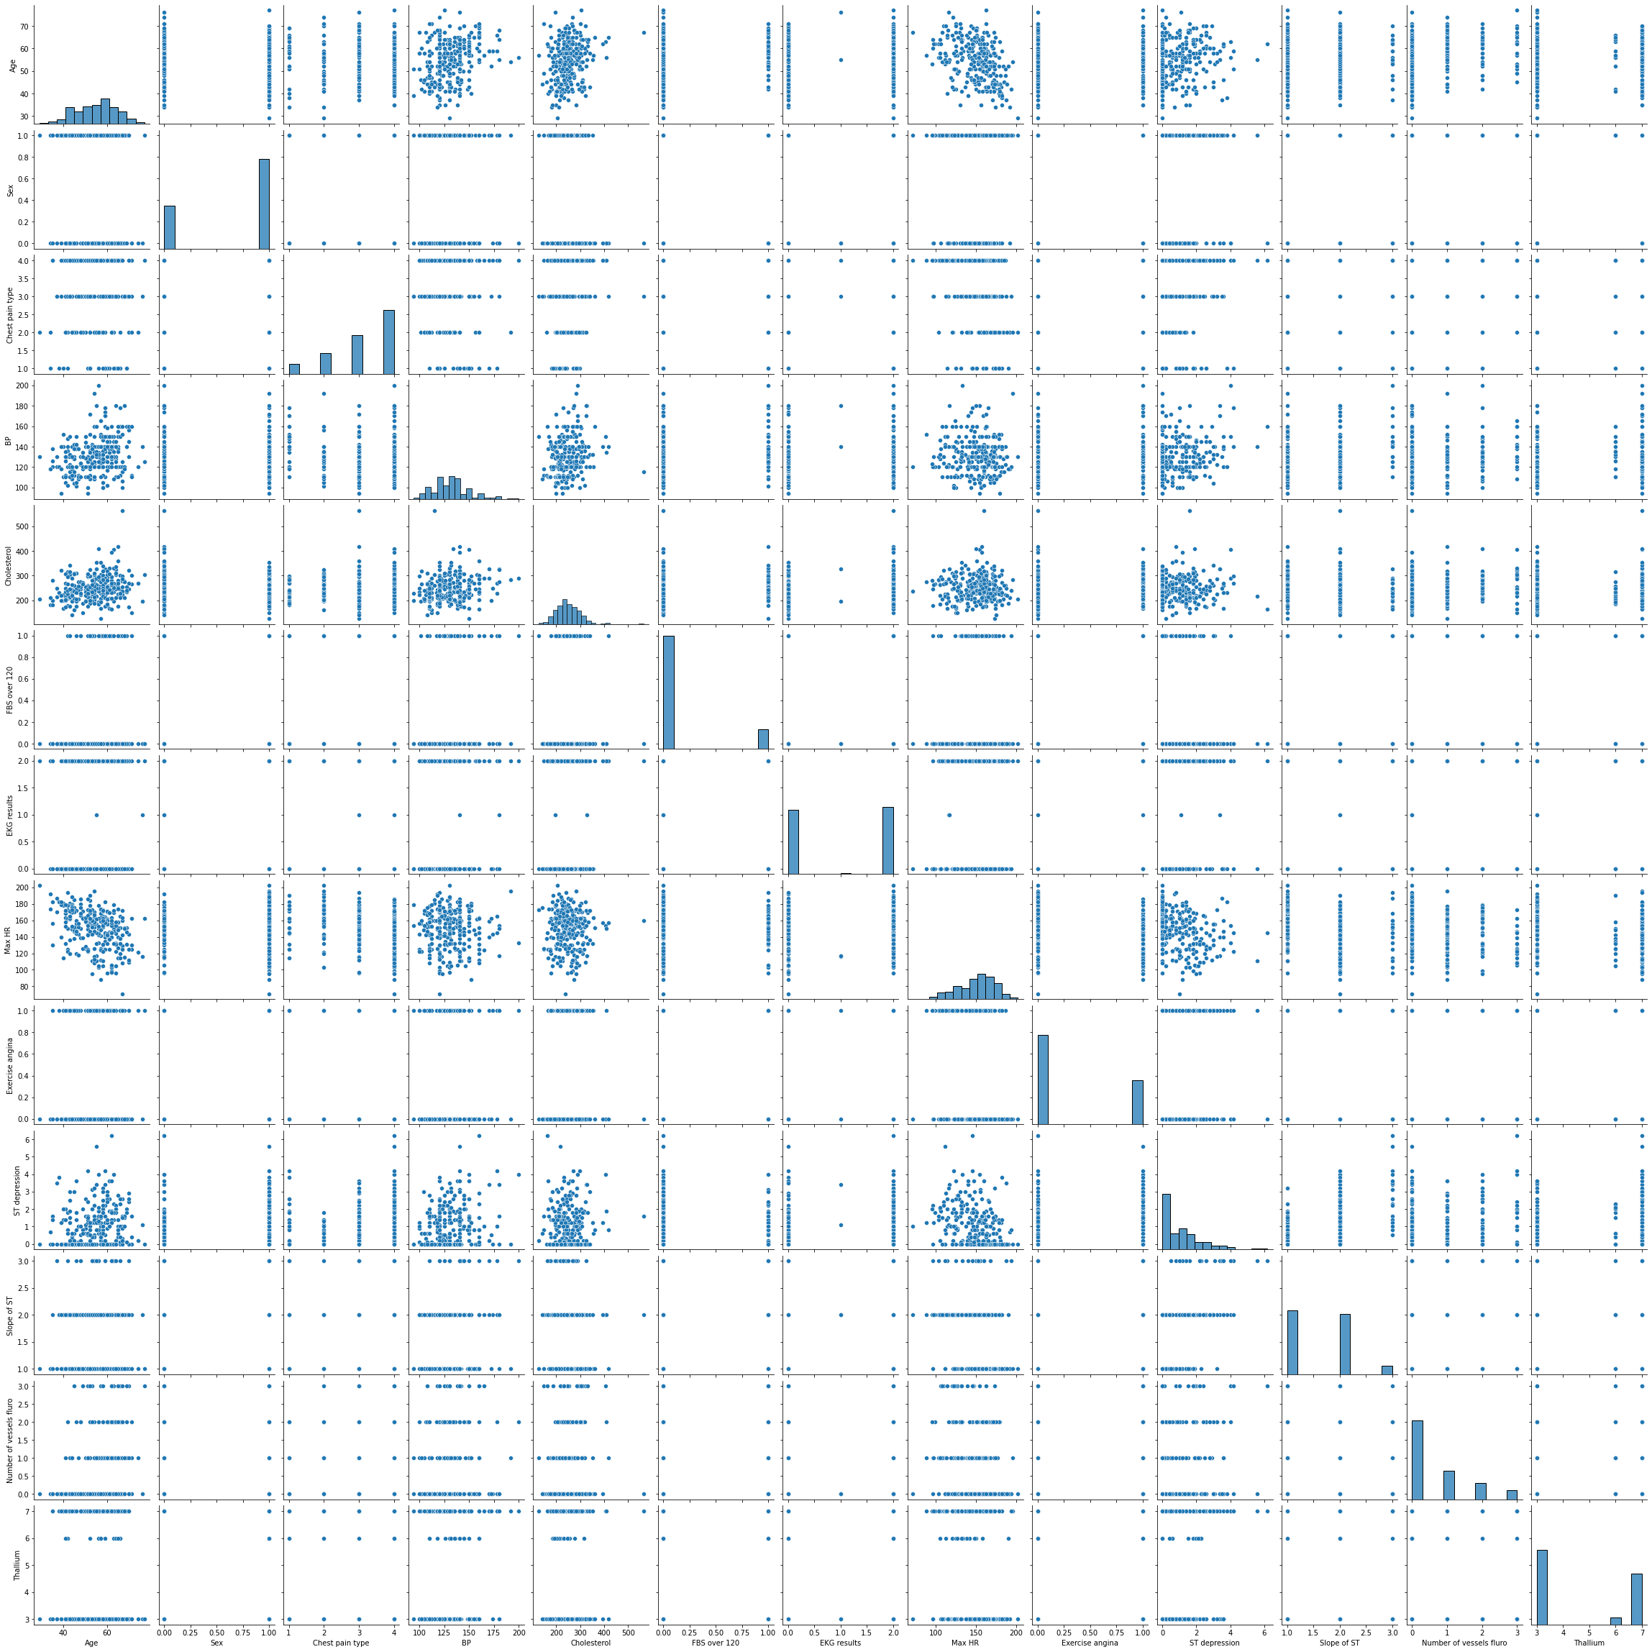

11/5/22, 1:25 AM Untitled2 - Jupyter Notebook

In [11]:

df.hist(figsize**=**(10,12), layout**=**(5,4));

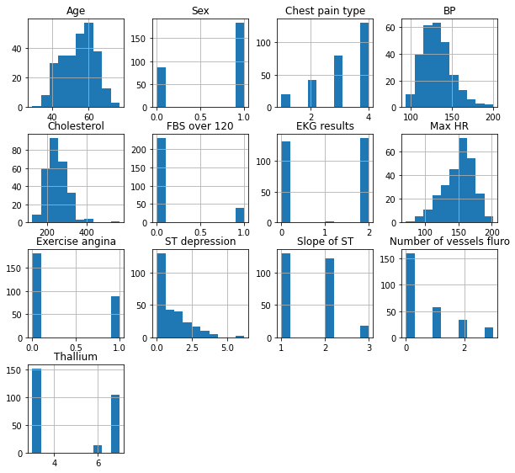

11/5/22, 1:25 AM Untitled2 - Jupyter Notebook

In [13]:

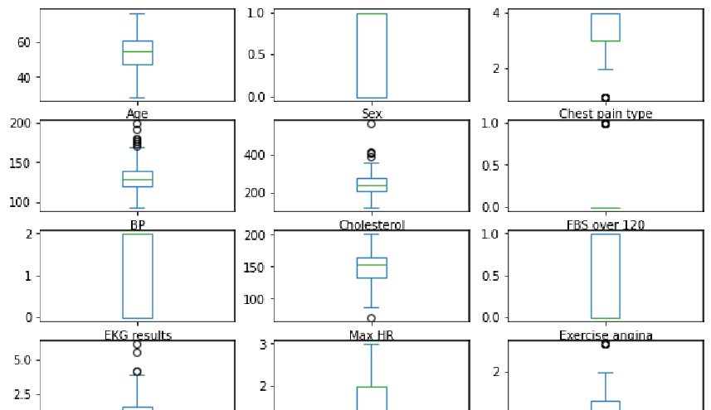

df.plot(kind**=**'box', subplots**=True**, layout**=**(6,3), figsize**=**(10,10)) plt.show()

In [19]:

sns.catplot(data**=**df, x**=**'Sex', y**=**'Age', hue**=**'Heart Disease', palette**=**'tab10')

Out[19]:

<seaborn.axisgrid.FacetGrid at 0x205a367dcc8>

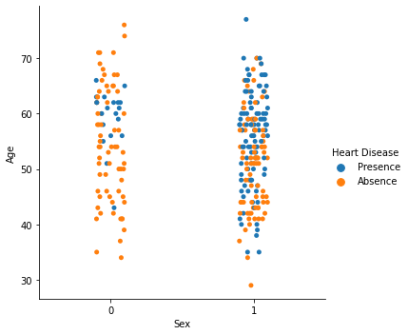

11/5/22, 1:25 AM Untitled2 - Jupyter Notebook

In [20]:

sns.barplot(data**=**df, x**=**'Sex', y**=**'Cholesterol', hue**=**'Heart Disease', palette**=**'spring')

Out[20]:

<AxesSubplot:xlabel='Sex', ylabel='Cholesterol'>

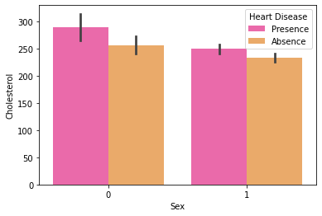

In [21]:

df['Sex'].value_counts()

Out[21]:

1 183

0 87

Name: Sex, dtype: int64

In [22]:

df['Chest pain type'].value_counts()

Out[22]:

4 129

3 79

2 42

1 20

Name: Chest pain type, dtype: int64

11/5/22, 1:25 AM Untitled2 - Jupyter Notebook

In [23]:

sns.countplot(x**=**'Chest pain type', hue**=**'Heart Disease' , data**=**df, palette**=**'rocket')

Out[23]:

<AxesSubplot:xlabel='Chest pain type', ylabel='count'>

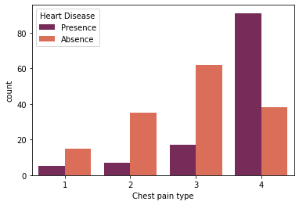

In [24]:

gen **=** pd.crosstab(df['Sex'], df['Heart Disease']) print(gen)

|  |  |  |  |
| --- | --- | --- | --- |
| Heart  Sex | Disease | Absence | Presence |
| 0 |  | 67 | 20 |
| 1 |  | 83 | 100 |

11/5/22, 1:25 AM Untitled2 - Jupyter Notebook

In [25]:

gen.plot(kind**=**'bar', stacked**=**'True', color**=**['green','blue'],grid**=False**)

Out[25]:

<AxesSubplot:xlabel='Sex'>

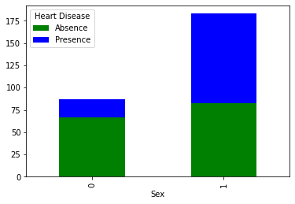

In [42]:

**from** sklearn.model_selection **import** train_test_split

**from** sklearn.preprocessing **import** StandardScaler StandardScaler **=** StandardScaler()

columns_to_scale**=**['Age', 'EKG results', 'Cholesterol', 'Thallium', 'Number of vessels fluro df[columns_to_scale] **=** StandardScaler.fit_transform(df[columns_to_scale])

In [43]:

df.head()

Out[43]:

**EKG**

|  |  |  |  |  |  |
| --- | --- | --- | --- | --- | --- |
|  | | **Chest** |  |  | **FBS** |
| **Age** | **Sex** | **pain** | **BP** | **Cholesterol** | **over** |

**results**

|  |  |  |  |  |  |  |  |  |  |  |
| --- | --- | --- | --- | --- | --- | --- | --- | --- | --- | --- |
|  | | **type** |  |  | **120** |  | | | | |
| **0** 1.712094 | 1 | 4 | 130 | 1.402212 | 0 | 0.981664 | 109 | 0 | 2.4 | 2 |
| **1** 1.382140 | 0 | 3 | 115 | 6.093004 | 0 | 0.981664 | 160 | 0 | 1.6 | 2 |
| **2** 0.282294 | 1 | 2 | 124 | 0.219823 | 0 | -1.026285 | 141 | 0 | 0.3 | 1 |
| **3** 1.052186 | 1 | 4 | 128 | 0.258589 | 0 | -1.026285 | 105 | 1 | 0.2 | 2 |
| **4** 2.152032 | 0 | 2 | 120 | 0.374890 | 0 | 0.981664 | 121 | 1 | 0.2 | 1 |

**Max HR**

**Exercise angina**

**ST**

**depression**

**Slope of ST**

11/5/22, 1:25 AM Untitled2 - Jupyter Notebook

In [44]:

**from** sklearn.model_selection **import** train_test_split

**from** sklearn.preprocessing **import** StandardScaler StandardScaler **=** StandardScaler()

columns_to_scale**=**['Age', 'EKG results', 'Cholesterol', 'Thallium', 'Number of vessels fluro df[columns_to_scale] **=** StandardScaler.fit_transform(df[columns_to_scale])

In [45]:

df.head()

Out[45]:

**Age Sex**

**Chest pain**

**BP Cholesterol**

**FBS**

**over**

**EKG**

**results**

|  |  |  |  |  |  |  |  |  |  |  |
| --- | --- | --- | --- | --- | --- | --- | --- | --- | --- | --- |
|  | | **type** |  |  | **120** |  | | | | |
| **0** 1.712094 | 1 | 4 | 130 | 1.402212 | 0 | 0.981664 | 109 | 0 | 2.4 | 2 |
| **1** 1.382140 | 0 | 3 | 115 | 6.093004 | 0 | 0.981664 | 160 | 0 | 1.6 | 2 |
| **2** 0.282294 | 1 | 2 | 124 | 0.219823 | 0 | -1.026285 | 141 | 0 | 0.3 | 1 |
| **3** 1.052186 | 1 | 4 | 128 | 0.258589 | 0 | -1.026285 | 105 | 1 | 0.2 | 2 |
| **4** 2.152032 | 0 | 2 | 120 | 0.374890 | 0 | 0.981664 | 121 | 1 | 0.2 | 1 |

**Max HR**

**Exercise angina**

**ST**

**depression**

**Slope of ST**

In [47]:

x**=**df.drop(['Heart Disease'], axis**=**1) y**=**df['Heart Disease']

In [48]:

x_train, x_test, y_train, y_test**=**train_test_split(x,y,test_size**=**0.3, random_state**=**40)

In [49]:

print('x_train-', x_train.size) print('x_test-', x_test.size)

print('y_train-', y_train.size) print('x_test-', x_test.size)

x_train- 2457

x_test- 1053

y_train- 189

x_test- 1053

11/5/22, 1:25 AM Untitled2 - Jupyter Notebook

In [73]:

**from** sklearn.linear_model **import** LogisticRegression lr**=**LogisticRegression()

model1**=**lr.fit(x_train,y_train)

prediction1**=**model1.predict(x_test)

In [54]:

**from** sklearn.metrics **import** confusion_matrix cm**=**confusion_matrix(y_test,prediction1)

cm

Out[54]:

array([[40, 5],

[ 9, 27]], dtype=int64)

In [56]:

sns.heatmap(cm, annot**=True**,cmap**=**'BuPu')

Out[56]:

<AxesSubplot:>

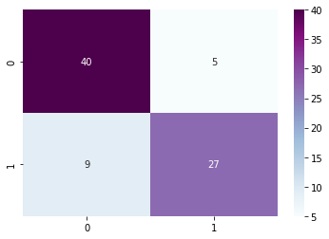

In [60]:

TP**=**cm[0][0]

TN**=**cm[1][1]

FN**=**cm[1][0]

FP**=**cm[0][1]

print('Testing Accuracy:', (TP**+**TN**+**FN)**/**(TP**+**TN**+**FN**+**FP))

Testing Accuracy: 0.9382716049382716

11/5/22, 1:25 AM Untitled2 - Jupyter Notebook

In [70]:

**from** sklearn.metrics **import** accuracy_score accuracy_score(y_test,prediction1)

Out[70]:

0.8271604938271605

In [62]:

**from** sklearn.metrics **import** classification_report print(classification_report(y_test, prediction1))

|  |  |  |  |  |
| --- | --- | --- | --- | --- |
|  | precision | recall | f1-score | support |
| Absence | 0.82 | 0.89 | 0.85 | 45 |
| Presence | 0.84 | 0.75 | 0.79 | 36 |
| accuracy |  |  | 0.83 | 81 |
| macro avg | 0.83 | 0.82 | 0.82 | 81 |
| weighted avg | 0.83 | 0.83 | 0.83 | 81 |

In [77]:

print('NB :', accuracy_score(y_test, prediction1))

NB : 0.8271604938271605